Name: Esha Tahir

Registration No: SP21-BSE-008

**Place Order**

**Brief Use case:**

The customer can edit his cart before placing the order. When the customer proceeds to checkout, he enters his personal information and selects an appropriate payment method. After that, he has to click on place order in order to confirm his order.

**Fully Dressed Use Case:**

|  |  |
| --- | --- |
| **Use case name** | **Place Order** |
| **Scope** | Infinity boutique |
| **Level** | User goal |
| **Primary actor** | Customer |
| **Stakeholder and interest** | * Customer: wants to buy the selected product. |
| **Precondition** | * If the customer wants to buy multiple items, he must add selected items to the cart. * The customer proceeds to checkout and enters his personal details. * The customer has to select a valid payment method. |
| **Success guarantee (post condition)** | The customer will get an order confirmation message. |
| **Main success scenario** | .   1. The customer finds the required item and adds it to the shopping cart. 2. The customer can edit his cart if he wants to add or remove a product. 3. The customer proceeds to checkout. 4. The customer must enter his details and shipping address. 5. The customer selects a payment method. 6. The customer clicks on place order to confirm the order. |
| **Exception** | At any time when a selected product is already sold out and the system fails to place the order:  • The customer will have to choose another item. |
| **Special requirement** | * The customer must have a stable internet connection. * The customer must have entered his valid details. |

|  |  |
| --- | --- |
| **Technology and**  **data variation**  **list** | The customer clicks on place order and an order confirmation message appears on the screen. |
| **Frequency of**  **occurrence** | • It will occur when the customer places an order. |
| **Miscellaneous** | Can a customer place multiple orders? |

**GUI Interface:**

**System Sequence Diagram:**

|  |  |
| --- | --- |
| Contract: Click on Place Order | |
| Operation | Click on Place order |
| Cross reference | Use case: Place order |
| Pre-Condition | The customer must have entered personal details.  The payment method should be selected |
| Post Condition | Thank you for ordering message will be displayed |

**Operation Contract:**

**Feedback**

**Brief use case:**

Customers gives feedback about the products bought from a specific boutique. They can share their experience about the products. Customers give feedback in two ways by comment and by rating. Admin view their feedback and give response on these feedbacks.

**Fully addressed use case:**

|  |  |  |  |
| --- | --- | --- | --- |
| **Use case name Feedback** | | | |
| **Scope** | | Infinity boutique | |
| **Level** | | User goal | |
| **Primary actor** | | Admin, User | |
| **Stakeholder**  **and interest** | | * Admin: wants to know how many customers are giving feedback. * Customer: Give feedback on the quality and quantity of products. | |
| **Precondition** | | Customer can give feedback after buying the product. | |
| **Success guarantee (post condition)** | | Admin View/ check the feedback. | |
| **Main success scenario** | | 1. The Customer give the feedback but first he will purchase the item from the boutique. 2. Admin view the customer’s Feedback. And take steps according to the feedbacks | |
| **Exception** | | When customer add feedback, but system can’t show their feedback the admin resolves this issue. | |
| **Special**  **requirement** | | If the customer wants to give feedback, then it will immediately do without taking any time. | |
| **Technology and**  **data variation**  **list** | | When customer give the feedback then system will show the message of “Thanks your feedback”. | |
| **Frequency of**  **occurrence** | | This will occur when customer want to give feedback. | |
| **Miscellaneous** | | How many customers give feedback? | |

**GUI Interface:**

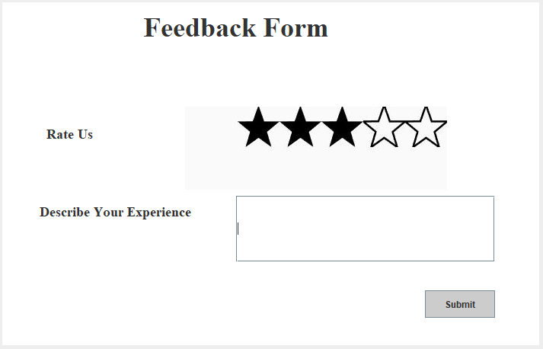

**System Sequence Diagram:**

**Operation Contract:**

|  |  |
| --- | --- |
| Contract: Clicked on give feedback | |
| Operation | Clicked on give feedback |
| Cross reference | Use case: Feedback |
| Pre-Condition | The customer should have purchased an item. |
| Post Condition | A feedback form will be displayed that will have an option to give ratings out of 5 starts or write a description. |

|  |  |
| --- | --- |
| Contract: Submit feedback | |
| Operation | Submit feedback |
| Cross reference | Use case: Feedback |
| Pre-Condition | The customer should have filled the feedback form |
| Post Condition | A thank you message will be displayed after submission of feedback. |